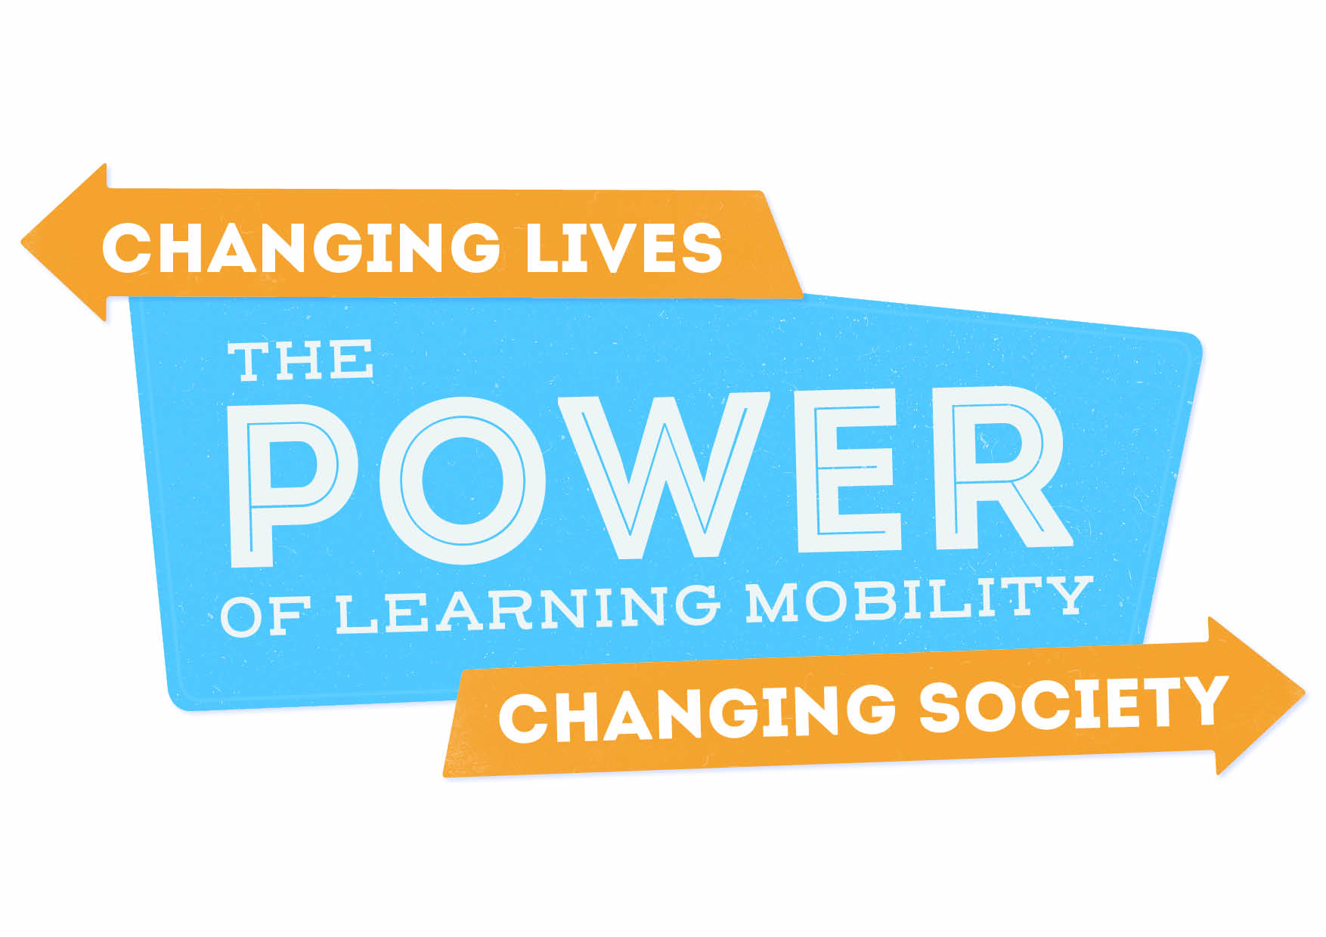

Call for participants!

EPLM conference
1 – 4 April 2019
Ostend, Belgium

Aim of the conference

This conference will look at the impact of quality learning mobility projects in the youth field, and the balance between personal and societal gain. It will explore what learning mobility means for communities and society at large, as well as individuals.

In a changing Europe, and changing political context, we believe that societal impact of learning mobility is one aspect which needs to be re-evaluated and promoted further.

Changing lives. It’s important to support: personal gain of individuals: development of competences, intercultural learning, increase of employability, developing European values, increase of personal investment and benefit…

Changing society. We should discover more how to: create a more cohesive society, the altruism that comes with making a community a better place, impact of volunteering on host communities, internationalisation at home, providing opportunities for all, increased contribution and gain through the interchange that learning can bring…

Questions for the Conference

Within quality learning mobility projects, how can we…

- Help young people to make (more of) a difference on a societal level?
- Ensure we are capitalising on the potential of the two-way impact of projects? (hosting community on the project and project on the community?).
- Assess the societal impact, from the perspectives of research, practice and policy?
- Balance the individual and societal gain of learning mobility projects? Which tools, methodologies and approaches work well?
- Ensure that these opportunities are not only for the privileged and the resourceful?
- …and more topics to be developed in the months leading up to the conference

EPLM and JINT involvement

The European Platform on Learning Mobility (EPLM) is coordinated by the youth partnership between the European Commission and the Council of Europe. It aims to improve knowledge, visibility and recognition of learning mobility in the youth field through exchange and cooperation of stakeholders (researchers, policy makers and practitioners). In previous years Germany, Hungary, Turkey and France have hosted the biennial EPLM conferences, also with the support of other National Agencies.
JINT (NA BE-FL) is contributing its expertise to focus on this 2019 one. It's an excellent occasion to celebrate learning mobility and the 30th anniversary of mobility programmes in Flanders.
More information about the background and development of the conference at the partnership webpage here.

The conference

It will be hosted in the Flemish town of Ostend, Belgium. Accommodation and conference costs will be covered through the Erasmus+ Youth in Action Programme, with support from the youth partnership between the Council of Europe and the European Commission. We welcome participants from all the countries of the Council of Europe and the Euromed region.

The conference programme will start 17h30 on Monday 1st April and will finish at 14h00 on Thursday 4th April 2019. Food and accommodation will be covered from dinner on the 1st April to lunch on 4th April 2019 (early arrival/later stay will not be covered or organised by the conference budget/team). An additional researchers’ networking meeting will be held from 10h00 – 17h00 on Monday 1st April.

Participant profile

There will be 150 people supported for this conference. As the EPLM supports the connection between research, practice and policy, this event should have representation from all of these, as well as young people themselves. The national delegations, of maximum 4 people per country, should be a mix representing these 7 different profiles (not more than one of each):

- Youth worker/NGO worker in the youth field
- Young person (age 18+), especially if they have a story to tell about how their learning mobility experience influenced them to make a (positive) impact on society
- Policy maker from local/regional/national level, related to youth policies
- Researcher (social scientists, and also including those who have other relevant pHd studies) with an interest/record in societal impact, especially from the youth field

- People from ‘local communities’ – those connected to society impact or social capital, rather than learning mobility
- Trainers from the youth field with a particular interest in societal impact from a practice, policy or research perspective.
- National Agency staff members

Representatives from IYNGOs and individual researchers will also be supported.

We ask the co-ordinating body (National Agencies, SALTOs, partnership, European Youth Forum etc) to pass on this call for participants with the concept paper, and to pre-select their delegation. Once pre-selected, the co-ordinating body should ask the participants to register using the online registration form, by 31st January 2019. You will get more information on the participant fee from your sending National Agency.

Community connection

We are organising single en-suite hotel rooms in the city of Ostend, within a 15 min walk of the conference venue. As this project focuses on community impact, we are also connected to local people to be involved for different reasons and different moments in the event. One part of this community-offer is a limited number of homestay spaces for accommodation. 10 lucky participants will get the chance to 'live' in an Ostend house during the event, staying 2 participants to each house in a shared bedroom, and have breakfast there each morning with their host. If selected, you would be put in contact with your host and sharing partner by email a few weeks before the event. If you are interested in this, give us your motivation for it in the registration form, and you might be one of the lucky 10!

Other information

Economy travel will be reimbursed through the National Agencies/SALTOs of your area.

A separate registration form will be made available for those playing a specific role in the conference (workshop facilitators, keynote speakers etc).

Please check the partnership website for more information about the background development of the conference.

Any questions regarding the process for delegations, registration, or about the conference itself to Susie Nicodemi, as co-ordinator for the event, by email on: PowerLM@jint.be

Timeline for the conference development

When | What
31st January 2019 | Registration deadline online for preselected participants
Mid-February 2019 | Waiting list confirmed
Mid-February 2019 | Whole participant group formed + first info pack (arrival time, travel, logistics) + link to needs form (diet, accommodation, etc)
By mid-March 2019 | Programme + last details sent to participants
1 April 2019 | Researchers meeting. Arrival day.
2 – 4 April 2019 | POWER conference
April – May 2019 | Follow-up, link to other events, EPLM Vision Paper for future steps

